Convert an Image to Show Outline using Canny Function
Code
import cv2
from google.colab.patches import cv2_imshow
from google.colab import files
uploaded=files.upload()
image_path=list(uploaded.keys())[0]
image=cv2.imread(image_path,cv2.IMREAD_GRAYSCALE)
if image is None:
print("Error: Image not found")
else:
edges=cv2.Canny(image,30,100)
print("Original Image")
cv2_imshow(image)
print("Canny Edge Image")
cv2_imshow(edges)
Input Image
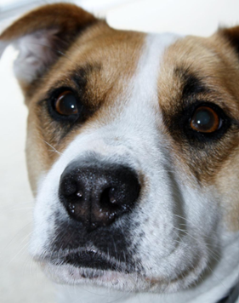

Output Image
Canny Edge Image
